LAB EXPERIMENTS
1. Implement and demonstrate the FIND-S algorithm for finding the most specific hypothesis based on a given set of training data samples.
CODE:
import pandas as pd
import random

# Load dataset
data = pd.read_excel("/content/enjoysport_persons.xlsx")

# Select required columns
data = data[['Sky', 'Temp', 'Humidity', 'Wind', 'EnjoySport']]

# Convert labels to binary
data['EnjoySport'] = data['EnjoySport'].map({'Yes': 1, 'No': 0})

# -------------------------------
# STEP 1: Take RANDOM 10 POSITIVE samples
# -------------------------------
positive_data = data[data['EnjoySport'] == 1]
sample_data = positive_data.sample(n=10, random_state=42)

print("Random Sampled Dataset Used:")
print(sample_data)

# -------------------------------
# STEP 2: FIND-S ALGORITHM
# -------------------------------
training_data = sample_data.iloc[:, :-1].values.tolist()

hypothesis = training_data[0].copy()

for instance in training_data:
for i in range(len(hypothesis)):
if hypothesis[i] != instance[i]:
hypothesis[i] = '?'

print("\nFinal Hypothesis:")
print(hypothesis)

# -------------------------------
# STEP 3: PREDICTION FUNCTION
# -------------------------------
def predict(instance, hypothesis):
for i in range(len(hypothesis)):
if hypothesis[i] != '?' and hypothesis[i] != instance[i]:
return 0
return 1

# -------------------------------
# STEP 4: EVALUATION
# -------------------------------
y_true = data['EnjoySport'].values
y_pred = data.iloc[:, :-1].apply(lambda row: predict(row.values, hypothesis), axis=1)

# Confusion Matrix values
TP = sum((y_pred == 1) & (y_true == 1))
FP = sum((y_pred == 1) & (y_true == 0))
TN = sum((y_pred == 0) & (y_true == 0))
FN = sum((y_pred == 0) & (y_true == 1))

# Metrics
accuracy = (TP + TN) / (TP + TN + FP + FN) * 100
precision = TP / (TP + FP) * 100 if (TP + FP) != 0 else 0

print("\nEvaluation Metrics:")
print(f"Accuracy : {accuracy:.2f} %")
print(f"Precision : {precision:.2f} %")

OUTPUT:
Random Sampled Dataset Used:
Sky Temp Humidity Wind EnjoySport
998 Cloudy Warm Normal Strong 1
756 Cloudy Cold High Strong 1
7 Sunny Warm High Weak 1
341 Cloudy Cold Normal Strong 1
151 Rainy Cold High Strong 1
570 Cloudy Cold Normal Strong 1
999 Sunny Cold High Weak 1
931 Sunny Cold Normal Strong 1
225 Cloudy Cold High Strong 1
253 Cloudy Warm High Strong 1

Final Hypothesis:
['?', '?', '?', '?']

Evaluation Metrics:
Accuracy : 52.30 %
Precision : 52.30 %

2. For a given set of training data examples stored in a .CSV file, implement and demonstrate the Candidate-Elimination algorithm in python to output a description of the set of all hypotheses consistent with the training examples

CODE:
import pandas as pd
# Load Excel file
excel_data = pd.read_excel("/content/enjoysport_persons.xlsx")
# Save as CSV
excel_data.to_csv("/content/enjoysport_persons.csv", index=False)
print("Excel file successfully converted to CSV")
import pandas as pd
# Load CSV
data = pd.read_csv("/content/enjoysport_persons.csv")
data = data[['Sky', 'Temp', 'Humidity', 'Wind', 'EnjoySport']]

# Take RANDOM samples (5 Yes + 5 No)
positive = data[data['EnjoySport'] == 'Yes'].sample(n=5, random_state=42)
negative = data[data['EnjoySport'] == 'No'].sample(n=5, random_state=42)
sample_data = pd.concat([positive, negative])
print("Sample Dataset Used:")
print(sample_data)
concepts = sample_data.iloc[:, :-1].values.tolist()
targets = sample_data.iloc[:, -1].values.tolist()
# Initialize S and G
S = concepts[0].copy()
G = [['?' for _ in range(len(S))]]
for i, instance in enumerate(concepts):
if targets[i] == 'Yes':
for j in range(len(S)):
if S[j] != instance[j]:
S[j] = '?'

G = [g for g in G if all(
g[j] == '?' or g[j] == S[j] for j in range(len(S))
)]
else: # Negative example
new_G = []
for g in G:
for j in range(len(S)):
if g[j] == '?' and S[j] != instance[j]:
temp = g.copy()
temp[j] = S[j]
new_G.append(temp)
G = new_G
# Remove duplicates
G = [list(x) for x in set(tuple(x) for x in G)]
print("\nFinal Specific Boundary (S):")
print(S)
print("\nFinal General Boundary (G):")
for g in G:
print(g)

OUTPUT:
Excel file successfully converted to CSV
Sample Dataset Used:
Sky Temp Humidity Wind EnjoySport
998 Cloudy Warm Normal Strong Yes
756 Cloudy Cold High Strong Yes
7 Sunny Warm High Weak Yes
341 Cloudy Cold Normal Strong Yes
151 Rainy Cold High Strong Yes
972 Rainy Cold Normal Weak No
77 Cloudy Warm Normal Weak No
290 Cloudy Warm High Weak No
147 Sunny Warm Normal Weak No
159 Rainy Cold High Weak No

Final Specific Boundary (S):
['?', '?', '?', '?']

Final General Boundary (G):
['?', '?', '?', '?']

3. Demonstrate the working of the decision tree based ID3 algorithm. Use an appropriate data set for building the decision tree and apply this knowledge to classify a new sample.
CODE:
# Step 1: Import Libraries
import pandas as pd
from sklearn.preprocessing import LabelEncoder
from sklearn.tree import DecisionTreeClassifier, plot_tree
import matplotlib.pyplot as plt
# Step 2: Load Dataset
data = pd.read_csv("/content/play_tennis.csv")
# Drop the 'day' column (just ID)
data = data.drop('day', axis=1)
# Step 3: Encode categorical features
le_dict = {}
for col in data.columns:
le = LabelEncoder()
data[col] = le.fit_transform(data[col])
le_dict[col] = le
# Separate features and target
X = data.iloc[:, :-1]
y = data.iloc[:, -1]
# Step 4: Train Decision Tree using ID3 (entropy)
clf = DecisionTreeClassifier(criterion='entropy')
clf.fit(X, y)
# Step 5: Display the tree (graphically)
plt.figure(figsize=(20,10))
plot_tree(clf,
feature_names=X.columns,
class_names=le_dict['play'].classes_,
filled=True,
rounded=True,
fontsize=12)
plt.title("Decision Tree (ID3) - Play Tennis Dataset")
plt.show()
# Step 6: Classify a new sample
new_sample = pd.DataFrame([["Sunny", "Cool", "High", "Weak"]],
columns=['outlook','temp','humidity','wind'])
# Encode new sample
for col in new_sample.columns:
le = le_dict[col]
new_sample[col] = le.transform(new_sample[col])
# Predict
prediction = clf.predict(new_sample)
predicted_class = le_dict['play'].inverse_transform(prediction)
print("\nNew Sample Prediction:")
print(new_sample)
print("Predicted Class:", predicted_class[0])

OUTPUT:
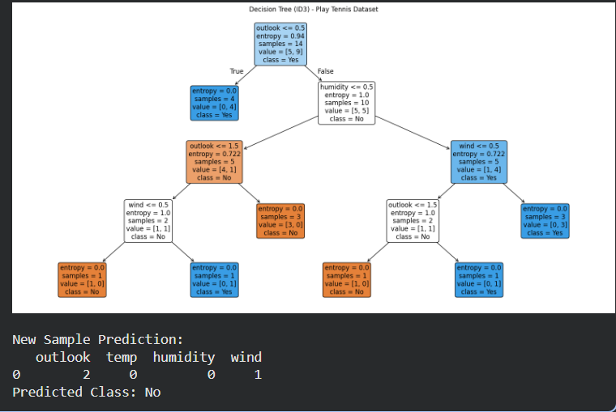

4. Build an Artificial Neural Network by implementing the Backpropagation algorithm and test the same using appropriate data sets.
CODE:
import numpy as np
import pandas as pd
from sklearn.model_selection import train_test_split
from sklearn.preprocessing import StandardScaler
# Load dataset
data = pd.read_csv("/content/diabetes.csv")
# Separate features and target
X = data.iloc[:, :-1].values
y = data.iloc[:, -1].values
# Normalize features
scaler = StandardScaler()
X = scaler.fit_transform(X)
# Train-test split
X_train, X_test, y_train, y_test = train_test_split(X, y, test_size=0.2, random_state=42)
# Convert target to one-hot encoding (binary classification)
y_train = y_train.reshape(-1, 1)
y_test = y_test.reshape(-1, 1)
# ANN Implementation (Backpropagation)
class NeuralNetwork:
def __init__(self, input_size, hidden_size, output_size, learning_rate=0.01, epochs=5000):
self.input_size = input_size
self.hidden_size = hidden_size
self.output_size = output_size
self.learning_rate = learning_rate
self.epochs = epochs

# Initialize weights
self.W1 = np.random.randn(self.input_size, self.hidden_size)
self.b1 = np.zeros((1, self.hidden_size))
self.W2 = np.random.randn(self.hidden_size, self.output_size)
self.b2 = np.zeros((1, self.output_size))

def sigmoid(self, z):
return 1 / (1 + np.exp(-z))

def sigmoid_derivative(self, z):
return z * (1 - z)
def train(self, X, y):
for epoch in range(self.epochs):
# Forward pass
z1 = np.dot(X, self.W1) + self.b1
a1 = self.sigmoid(z1)
z2 = np.dot(a1, self.W2) + self.b2
a2 = self.sigmoid(z2)
# Compute error
error = y - a2
# Backpropagation
d_a2 = error * self.sigmoid_derivative(a2)
d_W2 = np.dot(a1.T, d_a2)
d_b2 = np.sum(d_a2, axis=0, keepdims=True)
d_a1 = np.dot(d_a2, self.W2.T) * self.sigmoid_derivative(a1)
d_W1 = np.dot(X.T, d_a1)
d_b1 = np.sum(d_a1, axis=0, keepdims=True)

# Update weights
self.W1 += self.learning_rate * d_W1
self.b1 += self.learning_rate * d_b1
self.W2 += self.learning_rate * d_W2
self.b2 += self.learning_rate * d_b2
# Print loss occasionally
if epoch % 1000 == 0:
loss = np.mean(np.square(error))
print(f"Epoch {epoch}, Loss: {loss:.4f}")
def predict(self, X):
z1 = np.dot(X, self.W1) + self.b1
a1 = self.sigmoid(z1)
z2 = np.dot(a1, self.W2) + self.b2
a2 = self.sigmoid(z2)
return (a2 > 0.5).astype(int)
# Train and Test ANN
# Define network: input = 8 features, hidden = 10 neurons, output = 1 (binary classification)
nn = NeuralNetwork(input_size=X_train.shape[1], hidden_size=10, output_size=1, learning_rate=0.01, epochs=5000)
# Train
nn.train(X_train, y_train)
# Test
y_pred = nn.predict(X_test)
accuracy = np.mean(y_pred == y_test)
print(f"\nTest Accuracy: {accuracy * 100:.2f}%")

OUTPUT:
Epoch 0, Loss: 0.5621
Epoch 1000, Loss: 0.1196
Epoch 2000, Loss: 0.0978
Epoch 3000, Loss: 0.0870
Epoch 4000, Loss: 0.0797

Test Accuracy: 72.73%

5. Write a program for Implementation of K-Nearest Neighbours (K-NN) in Python
CODE:
import pandas as pd
from sklearn.model_selection import train_test_split
from sklearn.preprocessing import StandardScaler
from sklearn.neighbors import KNeighborsClassifier
from sklearn.metrics import accuracy_score, classification_report
# Load dataset (example: diabetes.csv)
# Replace with your dataset path
data = pd.read_csv("/content/diabetes.csv")
# Separate features and target
X = data.iloc[:, :-1].values
y = data.iloc[:, -1].values
# Preprocessing
scaler = StandardScaler()
X = scaler.fit_transform(X)
# Train-test split
X_train, X_test, y_train, y_test = train_test_split(
X, y, test_size=0.2, random_state=42
)
# KNN Classifier
k = 5 # number of neighbors
knn = KNeighborsClassifier(n_neighbors=k)
# Train
knn.fit(X_train, y_train)
# Predict
y_pred = knn.predict(X_test)
# Evaluation
print(f"Accuracy: {accuracy_score(y_test, y_pred) * 100:.2f}%")
print("\nClassification Report:\n", classification_report(y_test, y_pred))

OUTPUT:
Accuracy: 68.83%

Classification Report:
precision recall f1-score support

0 0.74 0.80 0.77 99
1 0.57 0.49 0.53 55

accuracy 0.69 154
macro avg 0.66 0.64 0.65 154
weighted avg 0.68 0.69 0.68 154

6.Write a program to implement Naïve Bayes algorithm in python and to display the results using confusion matrix and accuracy.
DATASET: Bengaluru House Price Data(CSV)
CODE:
import pandas as pd
from sklearn.model_selection import train_test_split
from sklearn.naive_bayes import GaussianNB
from sklearn.metrics import confusion_matrix, accuracy_score
data = pd.read_csv("Bengaluru_House_Data.csv")
data = data[['total_sqft', 'bedroom', 'price']].dropna()
data['total_sqft'] = pd.to_numeric(data['total_sqft'], errors='coerce')
data = data.dropna()
def price_category(price):
if price < 50:
return 0 # Low
elif price < 100:
return 1 # Medium
else:
return 2 # High

data['price_class'] = data['price'].apply(price_category)
X = data[['total_sqft', 'bedroom']]
y = data['price_class']
X_train, X_test, y_train, y_test = train_test_split(
X, y, test_size=0.3, random_state=42
)
model = GaussianNB()
model.fit(X_train, y_train)
y_pred = model.predict(X_test)
print("Naïve Bayes Classification Results")
print("Confusion Matrix:")
print(confusion_matrix(y_test, y_pred))
print("\nAccuracy:", accuracy_score(y_test, y_pred))

OUTPUT:
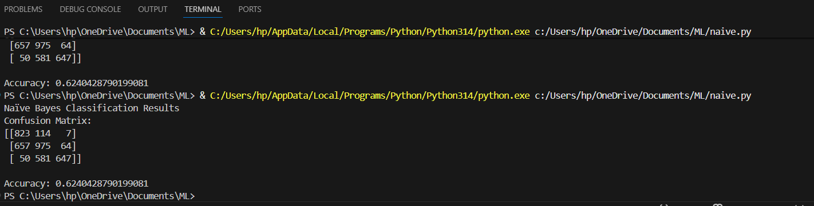

7. Write a program to implement Logistic Regression (LR) algorithm in python
Dataset: STUDENT EXAM DATA
CODE:
import pandas as pd
from sklearn.model_selection import train_test_split
from sklearn.preprocessing import StandardScaler
from sklearn.linear_model import LogisticRegression
from sklearn.metrics import confusion_matrix, classification_report, accuracy_score
# --- Load Dataset ---
df = pd.read_csv('/content/diabetes.csv')
# Features and labels
X = df.iloc[:, :-1].values # all columns except last
y = df.iloc[:, -1].values # last column (Outcome: 0 or 1)
# --- Standardize features ---
scaler = StandardScaler()
X = scaler.fit_transform(X)
# --- Train-test split ---
X_train, X_test, y_train, y_test = train_test_split(X, y, test_size=0.2, random_state=42)
# --- Logistic Regression Model ---
model = LogisticRegression()
model.fit(X_train, y_train)
# --- Predictions ---
y_pred = model.predict(X_test)
# --- Accuracy ---
accuracy = accuracy_score(y_test, y_pred)
print(f"Accuracy: {accuracy*100:.2f}%")
# --- Confusion Matrix ---
cm = confusion_matrix(y_test, y_pred)
print("\nConfusion Matrix:")
print(cm)
# --- Classification Report ---
cr = classification_report(y_test, y_pred)
print("\nClassification Report:")
print(cr)

OUTPUT:
Accuracy: 75.32%

Confusion Matrix:
[[79 20]
[18 37]]

Classification Report:
precision recall f1-score support

0 0.81 0.80 0.81 99
1 0.65 0.67 0.66 55

accuracy 0.75 154
macro avg 0.73 0.74 0.73 154
weighted avg 0.76 0.75 0.75 154

8. Write a program to implement Linear Regression (LR) algorithm in python
CODE:
import pandas as pd
import matplotlib.pyplot as plt
from sklearn.model_selection import train_test_split
from sklearn.linear_model import LinearRegression
from sklearn.preprocessing import OneHotEncoder
from sklearn.compose import ColumnTransformer
from sklearn.metrics import mean_squared_error, r2_score
# Load dataset
data = pd.read_csv("/content/insurance.csv")
# Separate features and target
X = data.drop("charges", axis=1)
y = data["charges"]
# Preprocessing (handle categorical variables)
categorical_features = ["sex", "smoker", "region"]
# One-hot encode categorical features
ct = ColumnTransformer(
transformers=[("encoder", OneHotEncoder(drop="first"), categorical_features)],
remainder="passthrough"
)
X = ct.fit_transform(X)
# Train-test split
X_train, X_test, y_train, y_test = train_test_split(
X, y, test_size=0.2, random_state=42
)
# Linear Regression Model
lr = LinearRegression()
lr.fit(X_train, y_train)

# Predict
y_pred = lr.predict(X_test)
# Evaluation
print("Mean Squared Error:", mean_squared_error(y_test, y_pred))
print("R2 Score:", r2_score(y_test, y_pred))
# Visualization: Actual vs Predicted
plt.scatter(y_test, y_pred, color="blue", alpha=0.6, label="Predicted vs Actual")
plt.plot([y_test.min(), y_test.max()],
[y_test.min(), y_test.max()],
color="red", linewidth=2, label="Perfect Prediction")
plt.xlabel("Actual Charges")
plt.ylabel("Predicted Charges")
plt.title("Linear Regression: Actual vs Predicted Charges")
plt.legend()
plt.show()

OUTPUT:
Mean Squared Error: 33596915.85136148
R2 Score: 0.7835929767120722
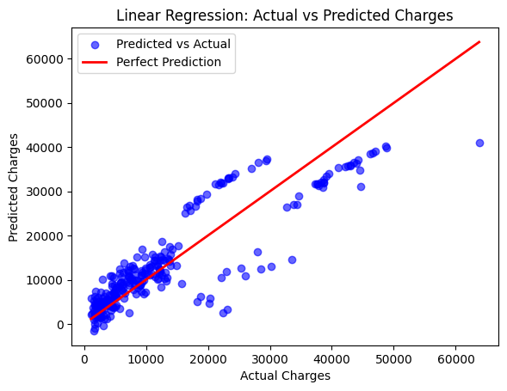
9.Compare Linear and Polynomial Regression using Python
CODE:
import pandas as pd
import matplotlib.pyplot as plt
from sklearn.model_selection import train_test_split
from sklearn.linear_model import LinearRegression
from sklearn.preprocessing import PolynomialFeatures, OneHotEncoder
from sklearn.compose import ColumnTransformer
from sklearn.metrics import mean_squared_error, r2_score
# Load dataset
data = pd.read_csv("/content/insurance.csv")
print(data.head())
# Separate features and target
X = data.drop("charges", axis=1)
y = data["charges"]
# Handle categorical variables
categorical_features = ["sex", "smoker", "region"]
ct = ColumnTransformer(
transformers=[("encoder", OneHotEncoder(drop="first"), categorical_features)],
remainder="passthrough"
)
X = ct.fit_transform(X)
# Train-test split
X_train, X_test, y_train, y_test = train_test_split(
X, y, test_size=0.2, random_state=42
)
# Linear Regression
lin_reg = LinearRegression()
lin_reg.fit(X_train, y_train)
y_pred_lin = lin_reg.predict(X_test)
print("Linear Regression MSE:", mean_squared_error(y_test, y_pred_lin))
print("Linear Regression R2:", r2_score(y_test, y_pred_lin))
# Polynomial Regression (degree=2)
poly = PolynomialFeatures(degree=2)
X_train_poly = poly.fit_transform(X_train)
X_test_poly = poly.transform(X_test)
poly_reg = LinearRegression()
poly_reg.fit(X_train_poly, y_train)
y_pred_poly = poly_reg.predict(X_test_poly)
print("Polynomial Regression MSE:", mean_squared_error(y_test, y_pred_poly))
print("Polynomial Regression R2:", r2_score(y_test, y_pred_poly))
# Visualization: Actual vs Predicted
plt.figure(figsize=(10,5))
plt.scatter(y_test, y_pred_lin, color="blue", alpha=0.6, label="Linear Regression")
plt.scatter(y_test, y_pred_poly, color="green", alpha=0.6, label="Polynomial Regression (deg=2)")
plt.plot([y_test.min(), y_test.max()],
[y_test.min(), y_test.max()],
color="red", linewidth=2, label="Perfect Prediction")
plt.xlabel("Actual Charges")
plt.ylabel("Predicted Charges")
plt.title("Linear vs Polynomial Regression on Insurance Dataset")
plt.legend()
plt.show()

OUTPUT:
age sex bmi children smoker region charges
0 19 female 27.900 0 yes southwest 16884.92400
1 18 male 33.770 1 no southeast 1725.55230
2 28 male 33.000 3 no southeast 4449.46200
3 33 male 22.705 0 no northwest 21984.47061
4 32 male 28.880 0 no northwest 3866.85520
Linear Regression MSE: 33596915.85136148
Linear Regression R2: 0.7835929767120722
Polynomial Regression MSE: 20712805.987918127
Polynomial Regression R2: 0.8665830903164855
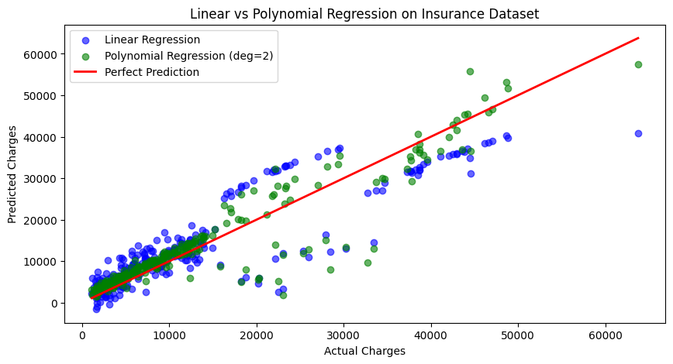

10. Write a Python Program to Implement Expectation & Maximization Algorithm
CODE:
import numpy as np
from sklearn.mixture import GaussianMixture
import matplotlib.pyplot as plt
# Step 1: Generate synthetic dataset
np.random.seed(42)
# Two Gaussian clusters
X1 = np.random.normal(loc=0.0, scale=1.0, size=200)
X2 = np.random.normal(loc=5.0, scale=1.5, size=200)
X = np.concatenate([X1, X2]).reshape(-1, 1)
# Step 2: Apply EM via Gaussian Mixture Model
gmm = GaussianMixture(n_components=2, random_state=42)
gmm.fit(X)
# Predict cluster assignments
labels = gmm.predict(X)
# Step 3: Print learned parameters
print("Means:", gmm.means_.flatten())
print("Variances:", gmm.covariances_.flatten())
print("Weights:", gmm.weights_.flatten())
# Step 4: Visualization
plt.figure(figsize=(8,5))
plt.hist(X[labels==0], bins=30, alpha=0.6, color='blue', label="Cluster 1")
plt.hist(X[labels==1], bins=30, alpha=0.6, color='green', label="Cluster 2")
plt.title("Expectation-Maximization (Gaussian Mixture Model)")
plt.xlabel("Data values")
plt.ylabel("Frequency")
plt.legend()
plt.show()

OUTPUT:
Means: [-0.07149398 5.09438815]
Variances: [0.80656076 2.23993587]
Weights: [0.49369545 0.50630455]
